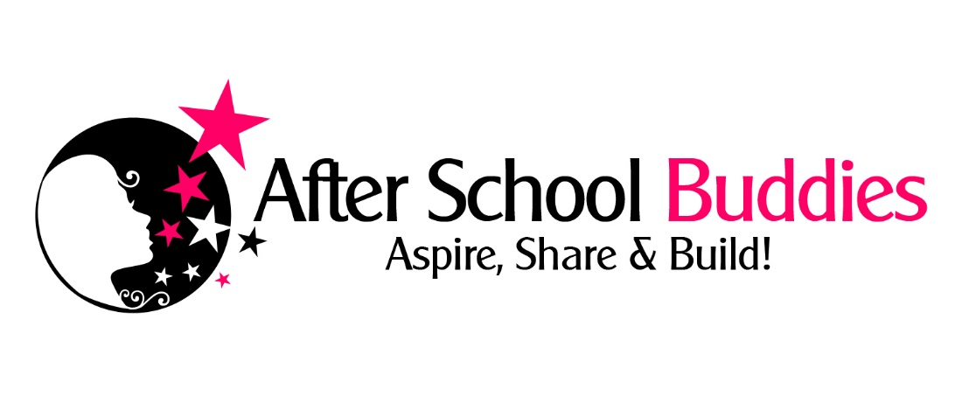

Adult Volunteer Application 2016/2017

Your Full Legal Name | First |  |  |  |  | Middle/Maiden
 | Last |  |  |  |  | Other/Previous Last
 | Birthdate |  |  |  |  | Place of Birth
Your Address |  |  |  |  |  |  |  | Zip Code
Your Phones | Home |  | Cell |  |  |  |  | Work
Your E-mail
Education  High School/College/Grad |  |  |  |  |  | Degrees  completed
Other certifications? CPR?
Spouse’s Name if married
Address if different |  |  |  |  |  |  |  |  | Zip Code
Spouse’s Phones | Home |  |  | Cell |  |  |  | Work
Spouse’s E-mail
Emergency Contact | Name |  |  |  |  |  | Cell Phone
Relationship to You
Have you been convicted of a federal crime before? | Yes No | Details:
Have you EVER been convicted of a sex-related crime? | Yes No | Details:
Have you EVER been convicted of a crime involving violence or threat of violence? | Yes No | Details:
Have you EVER been convicted of a crime involving criminal activity in drugs or alcoholic beverages? | Yes No | Details:
Driver’s License # | State | Number:
Your car insurance carrier | Name |  |  |  | Policy #
Do you have any special medical conditions?
Prescribed Medications -  What?/Dose? How often? | Name |  |  |  | Dose |  |  |  |  | How often
Other medical precautions we should know about.
Please indicate your home church/city if you have one.
Why do you want to volunteer for ASB?

Where else do you volunteer?
Please list the name, phone number and email address for 1 personal reference. Indicate how you know this person and for how long.
Are you currently employed? If so please list your employer and contact information.
If you work, what days/hours do you work?
What days/hours could you volunteer for ASB?
Other info you think we should know about you?
Advisory: A check of the applicant's criminal history will be made by After School Buddies, Inc. to verify the responses to the preceding questions.
I hereby grant After School Buddies, Inc. permission to check civil or criminal records to verify any statement made on this form. Regardless of whether the applicant grants consent, After School Buddies, Inc. will conduct a criminal offender record check of applicants for the position of volunteer working with or around children.
The applicant is entitled to review his/her criminal history for inaccurate or incomplete information. Discrimination by an employer on the basis of arrest records alone may violate federal civil rights law. The applicant may obtain further information concerning the applicant's rights by contacting the Bureau of Labor and Industries, Civil Rights Division, State Office Building, Suite 1070, Portland, Oregon 97232, telephone (503) 731-4075.
I acknowledge reading and the receipt of this notice.

Please return form to
Charlene Schulz, Director, After School Buddies, Inc. 62595 Hamby Rd. Bend OR 97701
Or scan and return electronically to afterschoolbuddies@gmail.com
AUTHORIZATION FOR MEDICAL TREATMENT
In case of accident or other emergency, I hereby give permission for After School Buddies, Inc. and/or its officers, officials, agents, contractors, volunteers, boards, departments, servants or employees, to obtain emergency medical treatment for me should medical treatment be required.

I acknowledge that After School Buddies, Inc. does not carry insurance to pay for the costs of medical treatment required by me and do further acknowledge and agree that any such medical or related expenses incurred by me will by my sole responsibility.

Initial Here __________

RELEASE OF LIABILITY AND INDEMNIFICATION AGREEMENT

For and in consideration of participate in the After School Buddies program I hereby voluntarily release, discharge, waive and relinquish any and all actions or causes of action for personal injury, property damage or wrongful death occurring to the before stated participant arising as a result of participation in said program or any activities incidental thereto wherever or however the same may occur and for whatever period said program may continue, and the undersigned parent/guardian does for him/herself, his/her heirs, executors, administrators and assigns hereby release, waive, discharge and relinquish any action or cause of action, which may hereafter arise for him/herself and for his/her estate, and agrees that under no circumstances will he/she or his/her heirs, executors, administrators and assigns prosecute or present any claim for personal injury, property damage or wrongful death against After School Buddies and its officers, officials, agents, contractors, volunteers, boards, departments, servants or employees for any of said causes of action, whether the same shall arise by the negligence of any of said persons, or otherwise.

IT IS MY INTENTION BY THIS INSTRUMENT, TO EXEMPT AND RELIEVE THE PARTICIPANTS of After School Buddies, Inc. AND THE RELATED PARTIES MENTIONED HEREIN, FROM ALL LIABILITY FOR PERSONAL INJURY, PROPERTY DAMAGE OR WRONGFUL DEATH CAUSED BY THE NEGLIGENCE OF ANY PERSON OR ENTITY.

In addition, I have been notified that participants involved in this program are subject to being photographed or videotaped, and I hereby give permission for After School Buddies to use such photographs or videotapes to publicize and promote this program unless we have specifically notified the program directors otherwise. Initial Here __________

I hereby expressly acknowledge and agree that:

1. There is a risk of injury, including serious and permanent injury or death, from my participation in the recreational activities involved in this program or event.
2. I knowingly and freely assume all risks of my participation in this program or event, and assume full responsibility for my participation.
3. The undersigned on behalf of him/herself, his/her heirs, executors, administrators or assigns agrees that in the event any claim for personal injuries, property damage or wrongful death shall be prosecuted against After School Buddies and/or its officers, officials, agents, contractors, volunteers, boards, departments, servants or employees, he/she shall defend, indemnify and save harmless the same After School Buddies, Inc. and the aforementioned related parties from any claim, cause of action, loss, liability, damage, lawsuit, cost or expense (including reasonable attorney’s fees) by whomever or wherever made or presented for said personal injuries, property damage or wrongful death.

The Undersigned acknowledges that I have personally read, understand, and voluntarily signed this release and waiver of all liability and indemnity agreement, am/are fully aware of the potential risk and hazards which are inherent to engaging in the specified recreational program or any activities incidental thereto, including but not limited to, any negligent acts performed by After School Buddies and/or its officers, officials, agents, contractors, volunteers, boards, departments, servants or employees, negligently created or maintained dangerous conditions of public property, weather conditions, equipment, machinery, playing conditions, other participants, on-site physical premises, structures or substantial works of improvement. The Undersigned voluntarily assumes all risks of loss, damage, or injury associated with my participation in the specified recreational program or any activity incidental thereto.

SIGNATURE:

(Printed name)

DATE:
(Your Signature)

