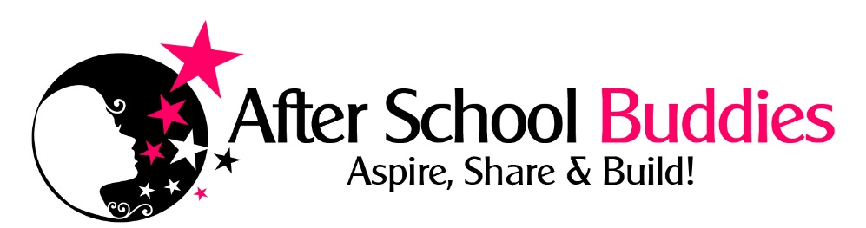

2017 SUMMER DAY CAMP Enrollment/Permission Slip

CAMPER’S INFORMATION
First Name: Last Name:
Fall 2017 School: FALL 2017 Grade:
Child’s Cell#: Age: Birthday:
Child’s 1 Address
City: Zip Code:

PARENT/GUARDIAN INFORMATION
Mom’s Name:
Mom’s Address w/zip if different than student’s
Mom’s Home Phone: Mom’s Cell:
Mom’s Email:
Dad’s Address w/zip if different than student’s
Dad’s Home Phone: Dad’s Cell:
Dad’s Email:

EMERGENCY CONTACT
Name: Cell #
GENERAL INFO
Person(s) Picking Up Child from Camp & Cell Phone #s:

Doctor’s Name: Phone/Clinic #:

Food Allergies / Medical Conditions? Medications Taken? Dose?
Seizures Y/N? If so – what to do?

Questions? 541 390-3046 or email afterschoolbuddies@gmail.com
Please complete the BOTH SIDES/PAGES of this form before returning. All forms should be returned to
Charlene Schulz, Executive Director After School Buddies, Inc. 62595 Hamby Rd. Bend OR 97701
AFTER SCHOOL BUDDIES, INC. AUTHORIZATION FOR MEDICAL TREATMENT
In case of accident or other emergency, I/we, the parent/legal guardian of the above stated participant, hereby give permission for After School Buddies, Inc. and/or its officers, officials, agents, contractors, volunteers, boards, departments, servants or employees, to obtain emergency medical treatment for participant should medical treatment be required.

I/WE acknowledge that After School Buddies, Inc. does not carry insurance to pay for the costs of medical treatment required by my/our child and do further acknowledge and agree that any such medical or related expenses incurred by my/our child will by my/our sole responsibility.
Parent’s Initial Here __________

RELEASE OF LIABILITY AND INDEMNIFICATION AGREEMENT

For and in consideration of permitting my/our child to enroll in and participate in the After School Buddies program I/we, the undersigned parent/guardian, hereby voluntarily release, discharge, waive and relinquish any and all actions or causes of action for personal injury, property damage or wrongful death occurring to the above stated participant arising as a result of participation in said program or any activities incidental thereto wherever or however the same may occur and for whatever period said program may continue, and the undersigned parent/guardian does for him/herself, his/her heirs, executors, administrators and assigns hereby release, waive, discharge and relinquish any action or cause of action, which may hereafter arise for him/herself and for his/her estate, and agrees that under no circumstances will he/she or his/her heirs, executors, administrators and assigns prosecute or present any claim for personal injury, property damage or wrongful death against After School Buddies and its officers, officials, agents, contractors, volunteers, boards, departments, servants or employees for any of said causes of action, whether the same shall arise by the negligence of any of said persons, or otherwise.

IT IS THE INTENTION OF the below signed parent/guardian BY THIS INSTRUMENT, TO EXEMPT AND RELIEVE THE PARTICIPANTS of After School Buddies, Inc. AND THE RELATED PARTIES MENTIONED HEREIN, FROM ALL LIABILITY FOR PERSONAL INJURY, PROPERTY DAMAGE OR WRONGFUL DEATH CAUSED BY THE NEGLIGENCE OF ANY PERSON OR ENTITY.

In addition, the undersigned parent/guardian has been notified that participants involved in this program are subject to being photographed or videotaped, and I/we hereby give permission for After School Buddies to use such photographs or videotapes to publicize and promote this program unless we have specifically notified the program directors to NOT include my child in publicity for the program. Parent’s Initial Here __________

I/we, the undersigned parent/guardian hereby expressly acknowledge and agree that:

1. There is a risk of injury, including serious and permanent injury or death, from my/our child's participation in the recreational activities involved in this program or event.
2. I/we knowingly and freely assume all risks of my/our child's participation in this program or event, and assume full responsibility for his/her participation.
3. The undersigned parent/guardian, on behalf of said participant and for him/herself, his/her heirs, executors, administrators or assigns agrees that in the event any claim for personal injuries, property damage or wrongful death shall be prosecuted against After School Buddies and/or its officers, officials, agents, contractors, volunteers, boards, departments, servants or employees, he/she shall defend, indemnify and save harmless the same After School Buddies, Inc. and the aforementioned related parties from any claim, cause of action, loss, liability, damage, lawsuit, cost or expense (including reasonable attorney’s fees) by whomever or wherever made or presented for said personal injuries, property damage or wrongful death.

The Undersigned acknowledges that I/we have personally read, understand, and voluntarily signed this release and waiver of all liability and indemnity agreement, am/are fully aware of the potential risk and hazards which are inherent to engaging in the specified recreational program or any activities incidental thereto, including but not limited to, any negligent acts performed by After School Buddies and/or its officers, officials, agents, contractors, volunteers, boards, departments, servants or employees, negligently created or maintained dangerous conditions of public property, weather conditions, equipment, machinery, playing conditions, other participants, on-site physical premises, structures or substantial works of improvement. The Undersigned voluntarily assumes all risks of loss, damage, or injury associated with his/her child’s participation in the specified recreational program or any activity incidental thereto.

SIGNATURE OF PARENT/LEGAL GUARDIAN: Child Name:

(Parent’s Printed name)

DATE:
(Parent’s Signature)

Please complete the BOTH sides of this form before returning. All forms should be returned to
Charlene Schulz After School Buddies, Inc. 62595 Hamby Rd. Bend OR 97701

